 | SAFETY DATA SHEET
 | SAFETY DATA SHEET | Doc. No.: SDS – AL008B
 | SAFETY DATA SHEET | Page: Page 1 of 6  Owner: SHEQ
 | SAFETY DATA SHEET | Rev. Date: S eptember, 2022
Oxygen (Liquid)
1 IDENTIFICATION OF THE SUBSTANCE / PREPARATION AND OF THE COMPANY / UNDERTAKING
Trade name MSDS No.  Chemical Formula  Company Identification |  | : Oxygen (Liquid)  : AL008B  : O2  : Janox BV  Roggestraat 12  8972 Krombeke  +32(0)57 30 98 40  Info@janox.be
2 HAZARDS IDENTIFICATION
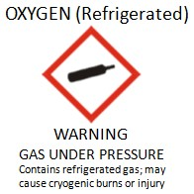
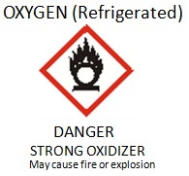
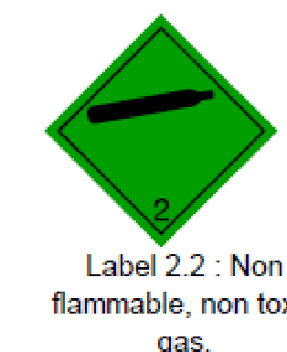
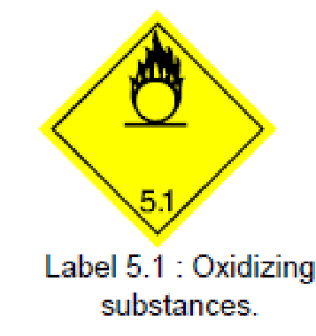

Classification of the substance
- Physical Hazard : Gases under pressure - refrigerated liquefied gas
: Oxidizing gas
- Health Hazard : no acute toxicity



Label Elements

- Hazard Pictogram

 | SAFETY DATA SHEET | Doc. No.: SDS – AL008B  Page: Page 2 of 6  Owner: SHEQ  Rev. Date: S eptember, 2022
Oxygen (Liquid)

- Signal word : Danger
- Hazard Statement : Contains refrigerated gas; may cause cryogenic burns or
injury
: May cause or intensify fire; oxidizer

2 HAZARDS IDENTIFICATION (continued)
- Precautionary statements  - Prevention  - Response o Storage  Other Hazard  - Other hazards | : Store away from combustible materials  : Keep reduction values free from grease and oil  Note: EIGA has proposed a new wording that has been accepted by the UN  WG on PS: “Keep value and fittings free from oil and grease”  : Wear cold insulating gloves / face shield / eye protection  : In case of fire, stop leak is safe to do so  : Store in a well ventilated area  Refrigerated liquefied gas. Contact with product may cause cold burns or frostbite. Strongly supports combustion. May react violently with combustible materials.
3 COMPOSITION / INFORMATIO N ON INGREDIENTS
Substance / Preparation : Substance

Substance Name Contents CAS No. EC No. Index No. Classification
Oxygen (refrigerated) 100% 7782-44-7 231-956-9 008-001-00-8 O; R8

Contains no other components or impurities which will influence the classification of the product.

4 FIRST AID MEASURES

First Aid Measures
- Inhalation |  | : Continuous inhalation of concentrations higher than 75% may cause nausea, dizziness, respiratory difficulty and convulsion.
 |  | Remove victim to uncontaminated area.
- Skin / Eye Contact |  | : Immediately flush eyes thoroughly with water for at least 15 minutes.  In case of frostbite spray with water for at least 15 minutes. Apply a sterile dressing. Obtain medical assistance.
- Ingestion |  | : Ingestion is not considered a potential route of exposure.

 | SAFETY DATA SHEET
 | SAFETY DATA SHEET | Doc. No.: SDS – AL008B
 | SAFETY DATA SHEET | Page: Page 3 of 6  Owner: SHEQ
 | SAFETY DATA SHEET | Rev. Date: S eptember, 2022
Oxygen (Liquid)

5 FIRE FIGHTING MEASURES

Flammable class | : Non flammable
Specific hazards | : Exposure to fire may cause containers to rupture / explode
Hazardous Combustion Products | : None
Extinguishing media  - Suitable extinguishing media | : All known extinguishants can be used.
Specific methods | : If possible stop flow of product.  Move away from the container and cool with water from a protected position. If leaking do not spray water onto container. Water surrounding area (from protected position) to contain fire.
Special protective equipment for fire fighters | : None
6 ACCIDENTAL RELEASE MEASURES

Storage : Segregate from flammable gases and other flammable
materials in store.
Keep container below 50 degrees C in a well ventilated place.
Handling : Use no oil or grease.
Open valves slowly to avoid pressure shock.
Suck back of water into the container must be prevented
Do not allow backfeed into the container.
Use only properly specified equipment which is suitable for this product, its supply pressure and temperature. Contact your gas supplier if in doubt.

 | SAFETY DATA SHEET
 | SAFETY DATA SHEET | Doc. No.: SDS – AL008B
 | SAFETY DATA SHEET | Page: Page 4 of 6  Owner: SHEQ
 | SAFETY DATA SHEET | Rev. Date: S eptember, 2022
Oxygen (Liquid)

7 HANDLING AND STORAGE (continued)

Keep away from ignition sources (including static discharge) Refer to supplier’s container handling instructions.

8 EXPOSURE CONTROLS / PERSONAL PROTECTION

Personal protection |  |  |  | : Do not smoke while handling product. Ensure adequate ventilation.
 |  |  |  | Protect eyes, face and skin from liquid splashes.
 |  |  |  | Avoid oxygen rich (>21%) atmospheres.

9 PHYSICAL AND CHEMICAL PROPERTIES

Physical state at 20 degrees C |  | : Refrigerated liquefied gas.
Colour |  | : Bluish liquid
Odo(u)r |  | : No odor warning properties
Molecular Weight |  | : 32
Melting point (degrees C) |  | : -219
Boiling point (degrees C) |  | : -183
Critical temperature (degrees C) |  | : -118
Vapour pressure, 20 degrees C |  | : Not Applicable
Relative density, gas (air =1) |  | : 1.1
Relative density, liquid (water = 1) |  | : 1.1
Solubility in water [mg/l] |  | : 39
Flammability range [vol% in air] |  | : Oxidiser
Auto – ignition temperature (degrees C) |  | : Not applicable

Other data : Gas/vapor heavier than air. May accumulate in confined spaces, particularly at or below ground level.

 | SAFETY DATA SHEET
 | SAFETY DATA SHEET | Doc. No.: SDS – AL008B
 | SAFETY DATA SHEET | Page: Page 5 of 6  Owner: SHEQ
 | SAFETY DATA SHEET | Rev. Date: S eptember, 2022
Oxygen (Liquid)

10 STABILITY AND REACTIVITY

Stability and reactivity | : May react violently with combustible materials.  May react violently with reducing agents.  Violently oxidizes organic material.  Liquid spillages can cause embrittlement of structural materials  Risk of explosion if split on organic structural materials (e.g.  wood or asphalt)
11 TOXICOLOGICAL INFORMATION
Toxicity information | : No toxicological effects from this product
12 ECOLOGICAL INFORMATION

Ecological effects information | : Can cause frost damage to vegetation.
13 DISPOSAL CONSIDERATIONS

General | : To atmosphere in a well ventilated place.  Do not discharge into any place where its accumulation could be dangerous.  Contact supplier if guidance is required.
14 TRANSPORT INFORMATION
UN No. : 1073
H.I. nr : 225
ADR / RID
- Proper shipping name : OXYGEN, REFRIGERATED LIQUID
- ADR Class : 2
- ADR / RID Classification code : 3 O
- Labelling ADR :
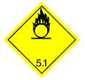
: 2.2: Non flammable, non toxic gas 5.1: Oxidizing substances

Doc. No.: SDS – AL008B
Page: Page 6 of 6
Owner: SHEQ

Rev. Date: S eptember, 2022

Oxygen (Liquid)

14 TRANSPORT INFORMATION (continued)

Other transport information : Avoid transport on vehicles where the load space is not separated from the driver’s compartment.
Ensure vehicle driver is aware of the potential hazards of the
load and knows what to do in the event of an accident or an emergency.
Before transporting product containers:
- Ensure that containers are firmly secured.
- Ensure cylinder valve is closed and not leaking.
- Ensure valve outlet cap nut or plug (where provided) is correctly fitted.
- Ensure valve protection device (where provided) is correctly fitted.
- Ensure there is adequate ventilation.
- Compliance with applicable regulations

15 REGULATORY INFORMATION

EC Classification | : Index No : 008-001-00-8  O; R8
EC Labelling  - Symbol (s) | : O: Oxidizng
- R Phrase (s) | : R8: Contact with combustible material may cause fire.
- S Phrase (s) | : S17: Keep away from combustible material.
16 OTHER INFORMATION
- May cause frostbite.
- Ensure all national / local regulations are observed.
- Ensure all operators understand the hazard of oxygen enrichment.
- This Material Safety Data Sheet has been established in accordance with the applicable European Directives and applies to all countries that have translated the Directives in their national laws.
- Before using this product in any new process or experiment, a thorough material compatibility and safety study should be carried out.
- Details given in this document are believed to be correct at the time of going to press. Whilst proper care has been taken in the preparation of this document, no liability for injury or damage resulting from its use can be accepted.

Recommended uses and restrictions: This MSDS is for information purposes only and is subject to change without prior notice. [Prior to purchase of products, please contact your local AIR LIQUIDE office for complete MSDS (with Manufacturer’s name and emergency phone number)].

End of Document

